Jonathan Disla

Assignment 1.5

Web 430

Prof. Krasso

Personal Portfolio Market Research

Milestone 1

For this assignment I searched on Google for the best web developer portfolios. The sites I have researched are mattfarly.ca, [caferati.me](https://caferati.me/) and pierre.io.

Features

For mattfarly.ca, it is a simple site that features the title of the developer as what services he can offer. It is a single page app that also displays an about section with an introduction of the developer. He then breaks down his experience in each field he says he is an expert in. He breaks it down by what he knows about the field and the technologies he understands about each field. There is then a few of his projects which when you hover over them a background overlay comes up and displays what the project is about. He then lists the companies he’s worked with. He then shows some of his own personal projects and lastly a testimonial from a client.

For Rafael Caferati he features a noticeable react single page app. There isn’t much scrolling rather there are left and right arrows as well as a navigation sandwich menu. He also shows social media icons on the home page. The second page shows the web developer portfolio. Hovering over a project displays an overlay that allows to break down the technologies used in each project. Clicking on a project takes you to a page displaying the features of the project. A user can scroll through a slider with pictures of the project.

For pierre.io he also displays a single page app that is scrollable. He features some advanced CSS animations and the mouse cursor is custom. First there is the bio and then his recent work which appears with a delayed fade animation. He then shows a list of companies he’s worked with and lastly his social media icons.

Advantages and Disadvantages

Best overall introduction

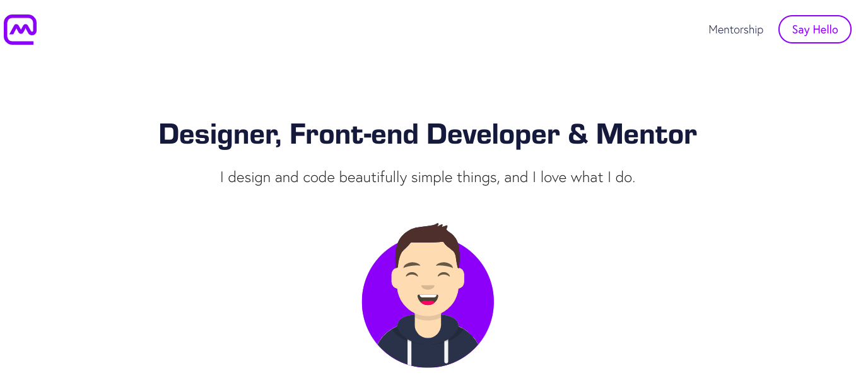

Best project detail section

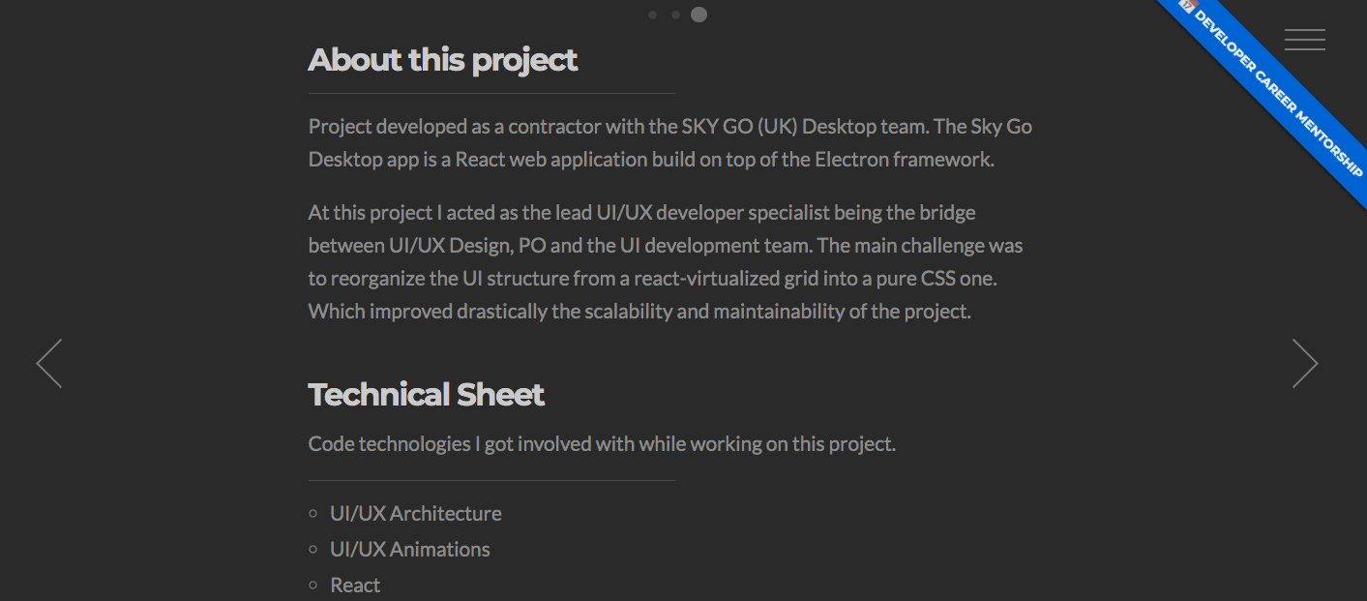

In the portfolios, both Farly and Caferati display interesting hover effects that show information on the project. In the case of Caferati, he also shows the technology that the project uses which is more complete.